**CE3606 :: JavaScript 2: Advanced JavaScript for websites and Web Applications**



Lecture 10 pt2

**Exercises sheet**

**Aristos Markogiannakis**

**Please use these notes together with my lecture presentation**

**Exercise 2**

**Step 1**

Add a Search component to the components folder

You will need to add the two files below

A) Search.js

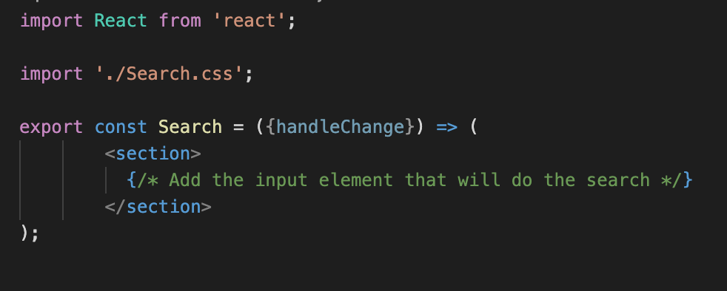

B) Search.css

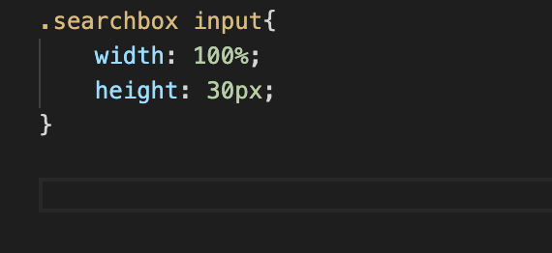

**Step 2:**

On **RatesContainer** import the Search component

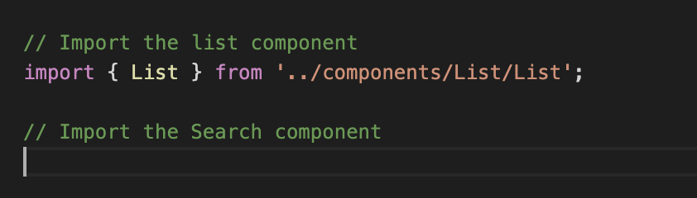

**Step 3:**

On RatesContainer inside the render method add the code to include the Search Tag

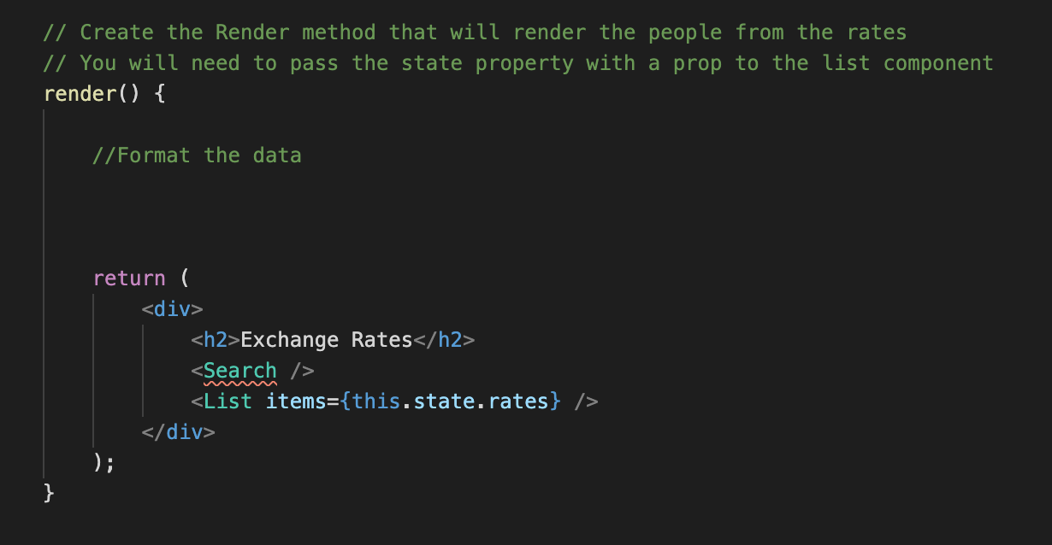

**Step 4:**

In the next step we will add the handler inside the Search component you will need to add a div that has a **className=”searchbox”.**

Inside the div add an input tag that has the following properties

* type=”text”
* Uses the onChange attribute and passes the property handleChange

**Step 5:**

Inside the render method we will need to add the handleChange property on the Search tag.

**<Searrch handleChange=”filterRates” />**

Step 6:

Modify the render method to match the following image

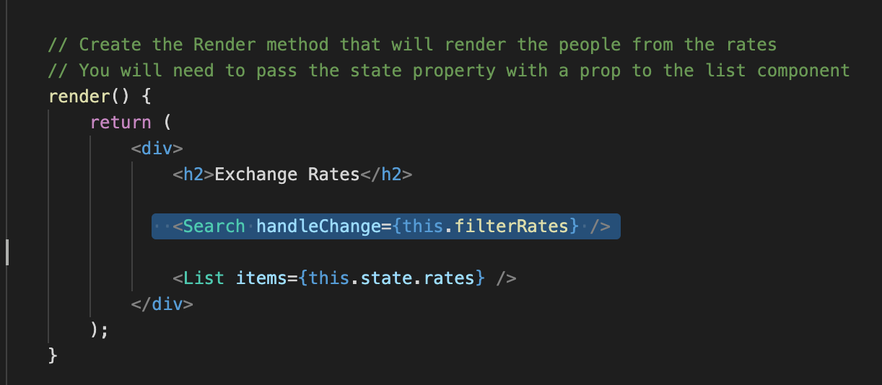

**Step 7:**

Add the filter Rates method inside the Rates Container.

rri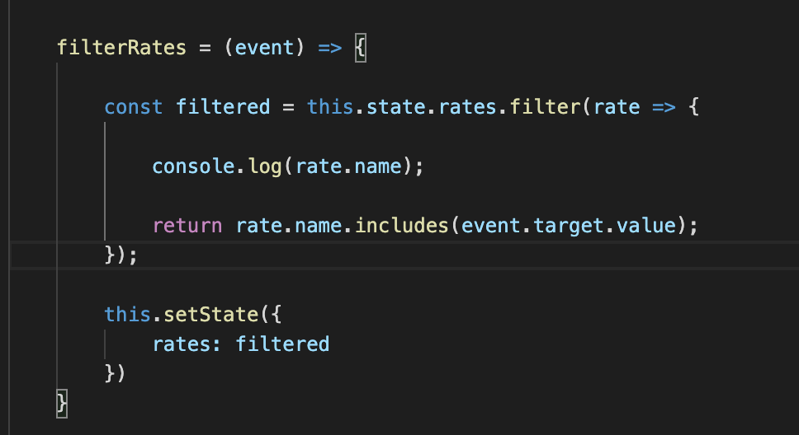

Step 8:

To run the app you will need to run **yarn start**

The final result should be as per the following image, when you type the word CAD it will bring you the following.

